SCIENCE Semester 1 Practice exam ONE /53½

- Suppose a person is enjoying a ride on a merry-go-round which is moving at a constant speed of 10 ms⁻¹ It implies that the person is
(a) at rest
(b) moving at a constant speed and a constant velocity
(c) moving at a constant speed but with a changing velocity
(d) moving with a changing speed but a constant velocity

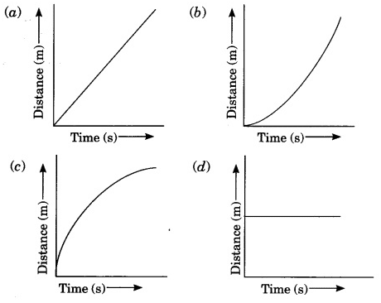
- Which of the following figures correctly represents the an object moving at constant speed?

- Which of the following statement is correct regarding velocity and speed of a moving body?
(a) Velocity of a moving body is always higher than its speed
(b) Speed of a moving body is always higher than its velocity
(c) Speed of a moving body is its velocity in a given direction
(d) Velocity of a moving body is its speed in a given direction

4. The property of a object at rest to remain at rest is known as
a. inertness
b. inertia
c. resistance
d. sluggishness

5. Gravitational potential energy depends on the ________, ________, and ________ of the object.
- Height, mass, and gravitational attraction
- Height, gravitational attraction, and weight
- Mass, Movement, and gravitational attraction
- Gravitational attraction, height and friction

6. What is the unit for Kinetic Energy?
- Newtons
- Grams
- Joules
- Kanye

7. The element found in the periodic table in Group 2 and period 4 is
A. Halfnium, Hf
B. Selenium, Se
C. Calcium, Ca
D. Gadolinium, Gd

8. How many electrons are there in the valence shell of a neutral atom of Oxygen and how many are there in the valence shell of the O^{2–} ion?
- 0 and 2
- 8 and 10
- 6 and 8
- 16 and 18

9. The Chemical formula of Zinc Hydroxide is
- ZNOH
- ZnOH
- Zn(OH)₂
- Zn₂OH
(9 marks)

10. Some students investigate the speed of cars. They measure the time it takes each car to travel a distance of 80 m. The table shows some of their results.
Colour of the car | Distance travelled (m) | Time (s)
Green | 80 | 5.0
Red | 80 | 4.0
Blue | 80 | 5.5
Black | 80 | 4.3
White | 80 | 5.6
- State the colour of the slowest car.

(1 mark)
- Calculate the speed of the black car.

(1 mark)
- Calculate the speed, in kilometres per hour, of the black car.

(1½ mark)
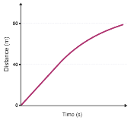
12. The distance-time graph for a car is shown below:
Describe what the graph shows about the speed of the car as it travels the 80 m.

(2 marks)
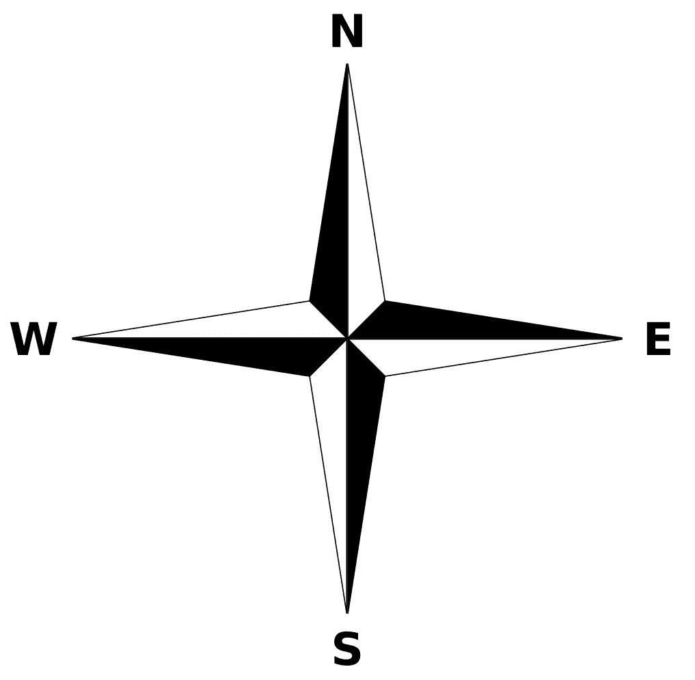
13. A girl walks a path through a rainforest that follows the curved shape shown on the diagram. The journey took her 2.5 hours.
13 km
4 km
Start
End
a. Calculate her speed in metres per second

(1½ mark)

b. Calculate her velocity in metres per second.

(1½ mark)

14. A car moves from rest, at traffic lights, to 15 m/s in 3.5 seconds.
- Calculate the acceleration of the car

(1½ mark)

- Is the final velocity of 15 m/s breaking the 50km/hr speed limit? Show your calculation to support your answer

(1 mark)

15. If a stationary ball with a mass of 200 g is hit with a force of 60 N, what will be the acceleration of the ball?

(1½ mark)

16. A common “magic” trick in a restaurant is to very quickly pull a tablecloth away, leaving the table setting (plates, glasses etc) undisturbed. Using your knowledge of newton’s first law of motion, explain how this is science, not magic.

(3 mark)
17. A car with a mass of 2000kg was at the top of a slope which was 15 metres high.
- What is the potential energy of the car relative to the flat ground?

(1½ mark)
- If the car is allowed to roll down the hill, calculate the velocity of the car at the bottom of the slope (assuming there is no friction)?

(2 mark)
18. Write definitions for
- Atom
- Proton
- Compound
(3 mark)

19. State the law of conservation of matter

(1 mark)

20. For each of the reactions below identify the TYPE of reaction it is and balance the chemical equation.
  - ______________________: ___ Al + ___ O₂ → ___ Al₂O₃
  - ______________________: ___ HgO → ___ Hg + ___ O₂
  - ______________________: ___ NaOH + ___ H₂SO₄ →  ___ Na₂SO₄ + ___ H₂O

(7½ mark)
21. Write a balanced chemical equation for a single displacement reaction between magnesium metal and calcium chloride

___________ + ___________ __________ + ___________

(4 mark)

22. Explain how concentration and using a catalyst can change the rate of a chemical reaction.

- Concentration
- Catalyst

(4 marks)

23. A student performed an experiment investigating the rata at which hydrogen peroxide (H₂O₂) reacted with iodine. The student varied the concentration of H₂O₂ and measured the time for each of the concentrations to completely react with a small amount of iodine.
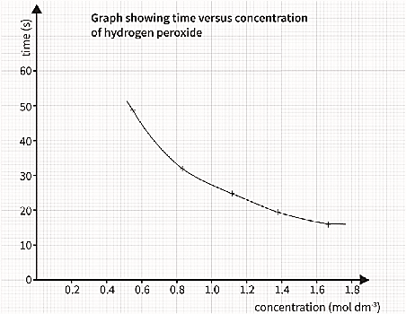
The student results are shown in the graph below.

- List the independent and the dependent variables for the reaction.

(2 marks)
- In one sentence describe the relationship shown in the graph.

(2 marks)

- List two variable which would have been controlled by the student during this experiment.

(2 marks)

HARDER A bullet with a mass of 50 g and travelling at 1200 m/s hits a person with a mass of 70 kg. Assuming the bullet remains with the body of the person, what will be the velocity at which the body is thrown backwards by the bullet?

